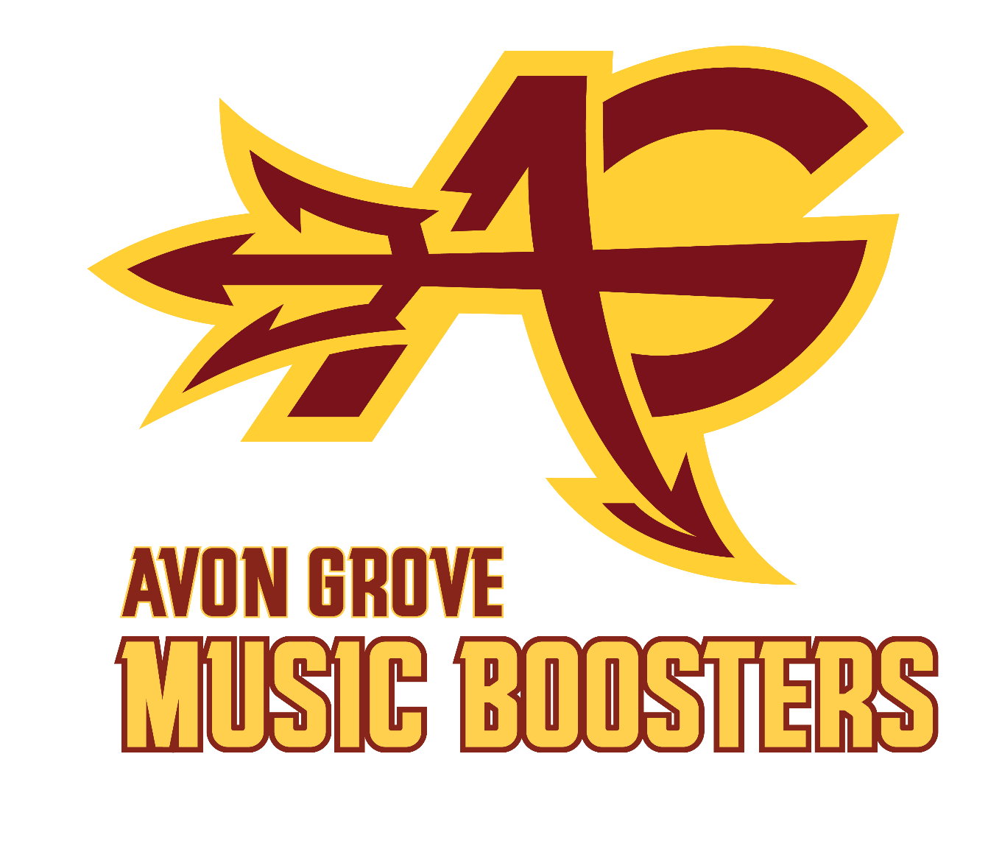
Avon Grove Instrumental Music Boosters
Parent and General Meeting Minutes
October 14, 2024 at 6:30pm in the AG Middle School Cafeteria

Attendees
Officers: Wendy Feller, Tascha Peterman, Matthew Miller, Shailendra Pendse, Susan Burns
Directors: none
Members: Serafina Anklin, Vicki Dixon, Mary Dunlap, Jason Feller, Michael Hill, Kate Kemelis, Harmony Laughlin, Bill Maley, Heather Miller, Eric Peterman, Claudia Scalia, Jessica Spencer

Call to Order
President Wendy Feller called the meeting to order at 6:37 p.m.

All parents had an opportunity to introduce themselves and share who their student(s) are and how they are involved with AG music programs.

Minutes
September meeting minutes were presented for review. No changes were noted. Eric Peterman entered a motion to approve minutes. Minutes were approved by a voice vote.

Music Department Directors Reports
- AGHS Choral Director Amanda Wilcox:
  - None provided
- Krista Umile, Orchestra Director:
  - PMEA District 12 Orchestra, Choir, and Band auditions are in November. These auditions are open to all sophomores, juniors and seniors that are enrolled in their curricular ensemble. If your student is auditioning, please ensure communication with the appropriate director has taken place (ASAP). Registration for each student will be done by directors in the near future.
    - Orchestra - Umile
    - Choir - Wilcox
    - Band - Davino
  - The AGHS Chamber Ensemble is a smaller group of string players who focus on learning and performing standard chamber repertoire. In addition to playing the seasonal concerts, the AGHS Chamber Ensemble has played events in and around the community including the Avon Grove Educational Foundation (AGEF) Fundraising Events, Boy Scouts Dinners, and lobby music before AGHS concerts. If there is an opportunity that you think would fit the AGHS Chamber Ensemble, please reach out to Krista Umile at kumile@avongrove.org
- Michelle Adcock, Color Guard Director:
  - Our fall guard is continuing to show growth and improved performances each week, along with the full band, with our show "Artificial". Shout out to our amazing parents who are working with the props to make this show come to life!
  - Indoor Guard is right around the corner! Our plan is to again have a high school team (grades 9-12) and a middle school team (6-8). But we will need enough members for that to happen, so any help getting the word out is greatly appreciated!
  - A complete calendar will be posted on the Schology groups soon, but for now our INFORMATIONAL MEETING will be on Wednesday, November 13 from 6:30-7:30 at AGIS. We will have a brief meeting for all in the cafeteria, then the students will move to the gym for a "spin clinic."
  - Please share the attached flyer, it includes the Schoology Join codes and an Interest form *I'll make a cuter graphic for web/insta sharing but feel free to share this online for now.

Treasurer's Report
Shout out to Matt from Wendy for all the time he spends on making sure our books are in order and our bills paid.

October Financial Report
September total monthly expenses - $12,794.00
· $8,414.91 – Purchase of Battery (Drumline) Instruments
· $1,120.00 – Cashbox withdraw for Football Game concessions
September total monthly Income - $8,314.00
· $4,019.00 – Football game concession sales (Cash)
· $2,059.00 – Football game concession sales (Square)
· $1054 – Donations

Fundraising events:
Game Owen J Roberts (9/13)
· Cash sales - $2,865.00
· Card sales - $2,132.00
· Transaction fees - ($572.15)
· Net sales - $4,924.85
Game Unionville (10/4)
· Cash sales - $3,170.00
· Card sales - $1,872.00
· Transaction fees - ($68.13)
· Net sales - $4,973.87
Homecoming Booth (10/5)
· Cash sales - $136
· Card sales - $140
· Transaction fees - ($4.83)
· Net sales - $271.17
Game Oxford (10/10)
· Cash sales - $2,925
· Card sales - $1,897
· Transaction fees - ($65.53)
· Net sales - $4,756.47

Marching Band fee payments
· 1 Unpaid, most likely to be Make Music Happen request
· 1 Partial, balance

Budget Spend
· Marching Band is operating under budget by $10,000 and more expenses anticipated.

Old Business
- Homecoming Recap - Rachel wasn’t able to be here, but shared notes. Shout out to Rachel, Kate, Tascha, Susan and Wendy for their work. We submitted a request to do a human slot machine, but found out 4 days before that we couldn’t do it. We switched gears and changed our game to Name that Tune.
  - We had some confusion when the kids came to play as to why they were there
  - Water and pretzel sales weren’t very good, other booths were selling for less.
  - Suggestion for a kids playlist too for the younger kids
  - Should evaluate the event purpose - fundraising or to just have a presence.
  - Maybe if we could have two tables, depending on our focus
  - There should be more space between tables, Heather plans to talk with Kyle Christy about this. There should be a space so you can get into your area.
- Volunteer Status -
  - SUGs are looking great.
  - We still need a driver for 10/26. Matt or Mike can drive. Tascha or Thad can navigate. This will get filled in on the SUG.
  - Championships needs some volunteers as well.
  - One more home game (10/25) and we need a large group for that.
- MS Band Night (10/10) - This was new - Mr. Haney said the kids and fun and it went well. We had little treats for them - thanks Matt for the idea. Next year we should provide a list of students to the ticket booth so they know those students don’t need tickets.
- Senior Night (10/25) - Need a photographer for senior night. Wendy reached out to Bob - if someone else is available if he isn’t or in addition, please let Wendy know. We already have a plan for parents for this. Senior parents are not available to help with fry trailer.
- Bylaws Amendments/Review - The bylaws are posted on the website here: forms-and-info.html. Holding until March to review after the busy seasons.

New Business
- Trunk-or-Treat: this will be at practice on 10/31 at 8:30 p.m. We can set up at the stadium. If we can have someone mark off an area right after the middle school busses leave to keep people from parking in the area. Tascha is usually there early to set up, so can be the contact if people have questions. This is an opportunity for parents to pass out candy for the band members after they have practice.
- States/Nationals - We do have candy leftover from homecoming. Thought we could hand that out to the kids on the bus. Maybe gatorade or propel for Nationals.
- Indoor Guard (11/13) and Percussion (11/12) Interest Meetings flyers are posted in the Marching Band Group on Schoology and https://www.agimba.org/
- Medbag - restock - there was discussion about whether this should be the responsibility of AGIMBA since this is a school function. Bob Ruddy took the bag home and cleaned it out, reorganized it. Isn’t this part of what the fee is for that is paid to the school? This will be discussed with the director and Kyle Christy.
- Fundraising/Budgetary Wants & Needs - 5 year forecast
  - We get annual budgets from the music programs.
  - AGIMBA pays for the truck, the maintenance, etc.
  - Brainstormed ideas for future wants & needs. This list is not exhausted - additional ideas can be shared with a member of the executive committee.
    - A nicer banquet for marching band. Banquets for indoor percussion & winter guard
    - states/nationals shirts (if we win states?)
    - Letterman jackets
    - Overnight trip to states or nationals
    - Volunteer shirts
    - Upgrade the fry trailer and burger stations
      - Add a second concession stand or get a food truck
    - A golf cart with trailer to move the equipment
    - Review current storage trailers and upgrade if needed
    - Band camp activities
    - Clinic for elementary students
    - Clinics for other groups and instructors - open beyond AG
    - Instrument replacement
    - Poster like what senior football players and cheerleaders get
    - Better storage facility and props
    - Tri-M support/recognition gift
    - Scholarships - expand this
    - Video streaming - copy right fees, recording gear
    - Offset student fees
    - Uniforms and prop supplement
    - AGIMBA socials
    - Picnic after Memorial Day parade, family events
    - Booster program collaboration site and/or email business account

Committee Reports
- SCRIP/RaiseRight
  - SCRIP REPORT for orders placed between 9/1/2024 and 9/30/2024.
  - 12 families placed orders during this time period.
  - Total earned in Scrip rebates was $328.12.
  - Boosters made $160.72, after $11.00 in shipping expenses. $156.40 went to student accounts.
  - Total income for Fiscal Year (July 1, 2024 to June 30, 2025): $796.92, which is split between Boosters and student accounts.
  - Total expenses for Fiscal Year: $11.00 shipping/$0 supplies (comes off booster rebates earned)
  - The next order due date for Scrip "Ship to Coordinator" processing is OCT 31,2024 - (Thursday due to Trunk or Treat Weds. night).
- Fry Trailer - Jason shared
  - Shout out to Heather for getting and bringing ice to all the home football games
  - One more game to go. Averaging 71 bags of fries, roughly 440 orders. It was Wildcats night, Oxford is close and they invited 100 students to attend for free, this likely increased their attendance.
  - Changed some things that have improved flow and others that haven’t worked out as planned. Jason places his next order this Friday, so let him know if there are any notes.
  - Will be trying to run as close to empty as possible for this last game so we don’t have excess inventory.
  - Thanks to all the volunteers for the hard work they do to make this fundraiser work.
  - The group thanked Jason for taking a lead on this.
- Having the assistance at the end of the night to break down is invaluable
- Spiritwear - Natalie is getting pricing from a vendor - Atlantic Sportswear. Other teams go with that. There will be a holiday sale, but unsure if we can switch over to them. May still be Triple Barn for the holiday order. There will be another sale in the winter for the indoor programs. Looking into what percentage we would make on each project.
- Band Banquet - The two dates are between Thursday 11/14 or Friday 11/22. This date will soon be finalized. The committee met to plan earlier today
- Santa Breakfast - The Santa Breakfast is scheduled for Saturday, December 14, 2024 from 8:00 - 10:30 a.m. Got 5 new sponsors for the breakfast.

We are missing many volunteer lanyards, we should update them with the new logo.
Shout out to Bob for his emails to entice people to volunteer.

Next Meeting: Monday, November 11, 2024 at 6:30 PM in the AGHS Cafeteria - meetings are open to all families with students participating in music programs.

Meeting Adjourned at 8:10 pm

Fall Upcoming Important Dates: (also on website)

Month | What | Date | Time
October
 | Away FB game- performance | 10/18 | 7:00 PM
 | Competition (Upper Dublin) | 10/19 | 6:00 PM
 | Tri-M induction Concert | 10/24
 | Home FB game (Senior Night) | 10/25 | 7:00 PM
 | MB State Championships (Upper Moreland) | 10/26 | 6:00 PM
 | Trunk or Treat - Marching Band/Guard | 10/30 | 8:30 PM
November
 | MB Friends and Family Show | 11/2 | 10:00 AM
 | Marching Band Nationals | 11/9
 | AGIMBA General Meeting | 11/11 | 6:30 PM
 | Indoor Guard Interest Meeting (AGIS Cafe) | 11/12
 | Indoor Percussion Interest Meeting (HS Band Room) | 11/13
 | Band Banquet | 11/22
December
 | AGIMBA General Meeting | 12/9 | 6:30 PM
 | Santa Breakfast | 12/14 | 8:00 AM
 | Concert Band Winter Concert | 12/11 | 7:00 PM
 | Choir Winter Concert | 12/4 | 7:00 PM
 | Orchestra Winter Concert | 12/10 | 7:00 PM

AGIMBA Executive Committee
ROLE | NAME | EMAIL
President | Wendy Feller | agimba.pres@gmail.com
Vice President | Tascha Peterman | agimba.vicepres@gmail.com
Secretary | Susan Burns | agimba.sec@gmail.com
Treasurer | Matt Miller | agimba.tres@gmail.com
Assistant Treasurer | Shailendra Pendse | agimba.tres@gmail.com
Committee Chairs
Communications | Bob Ruddy | agimba.comms@gmail.com
Website | Eric Peterman | crazekayakr@gmail.com
Homecoming | Drum Major Parents | rachelkarnes@hotmail.com
Band Camp | Wendy Feller | agimba.pres@gmail.com
Band Banquet | Jessi Spencer
Devil Fry Trailer | Jason Feller | jason.r.feller@gmail.com
 | Brian Burns | bmburns@hotmail.com
Santa Breakfast | Wendy Feller | agimba.pres@gmail.com
Fundraising | Wendy and Jason Feller | agimba.pres@gmail.com
Raiseright/SCRIP | Eric Peterman | crazekayakr@gmail.com
Volunteer Coordinator | Julie Weaver | valjul@verizon.net
Spiritwear | Natalie Campbell | ndcvmd98@gmail.com
Uniforms Manager | Poorva Pendse | pendse.poorva@gmail.com
Show Props | Michael Hill | Myshadow70@gmail.com
Indoor Guard & Percussion Shows | Wendy Feller | agimba.pres@gmail.com
 | Eric Peterman | crazekayakr@gmail.com
Jazz Night | Val and Julie Weaver | valjul@verizon.net
MB Commitment Night | Wendy Feller | agimba.pres@gmail.com
MB Commitment Night | Susan Burns | 4susanburns@gmail.com

