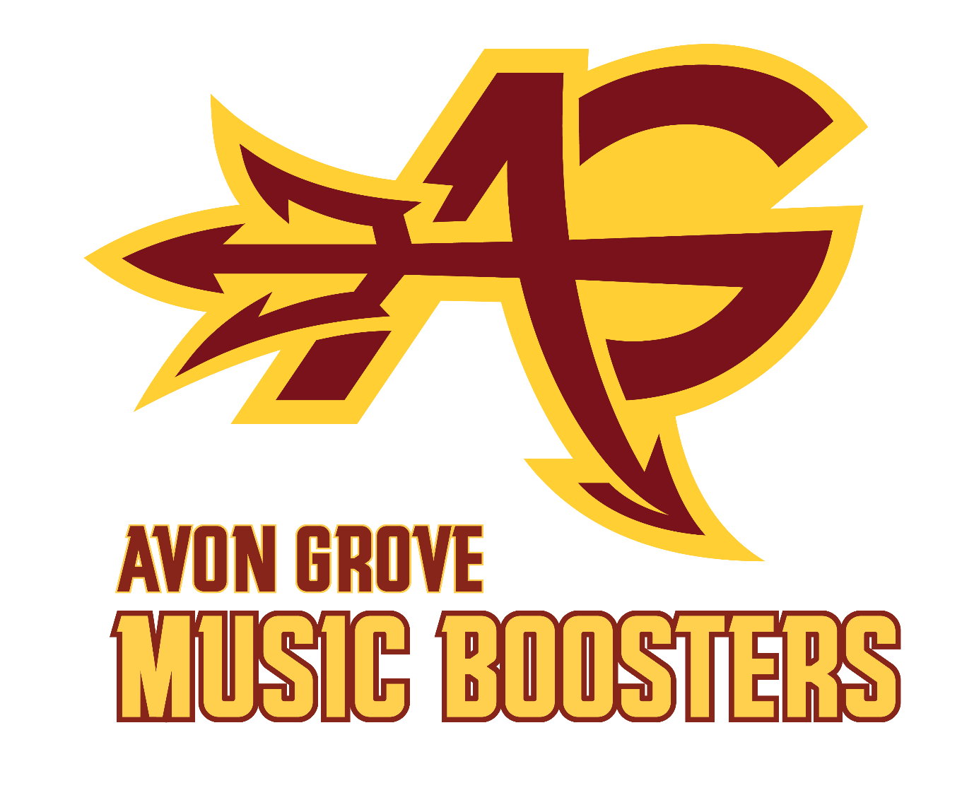
Avon Grove Instrumental Music Boosters
Parent and General Meeting Minutes
May 12, 2025 at 6:30 pm in the AG High School Cafeteria
https://www.agimba.org/

Attendees
Officers: Wendy Feller, Tascha Peterman, Matthew Miller
Directors: None present
Members: Liz Scheibe, Eric Peterman, Jason Feller, Michael Hill, Heather Miller, Bill Maley, Shannon Giordano, Natalie Campbell, Shailendra Pendse, Harmony Laughlin

Call to Order
President Wendy Feller called the meeting to order at 6:31 p.m.

Minutes
April meeting minutes were accepted by voice vote.

Director’s and District Reports
High School Athletics and Student Activities Director Report- Kyle Christy absent, but sent in the following:
“I am getting Dennis information for the Engle Parking Lot so that lines are going to be accurately marked for the season (since this lot will be resealed after the construction is completed).”

Music Department Directors Reports
- Michael Davino, AGHS Band Director
  - No report
- Amanda Wilcox, AGHS Choral Director:
  - No report
- Krista Umile, Orchestra Director:
  - No report
- Michelle Adcock, Color Guard Director:
  - A HUGE thank you and shout out to the organizers of the first ever Indoor Groups banquet. It was an amazing night and the kids had a blast. Thank you all so much for what you do for our students! We LOVE this new tradition!
  - I will need 2-4 people to help me measure the color guard at the last two orientation days: Wednesday 5/28 and Monday 6/2. I'll have everything set up on a Google form, just bring measuring tape if you have it.
  - I would like to set up a planning meeting for props for the fall marching band show. If we could have the "prop committee" meet during the orientation on 5/28 that would be great. If not, let's work out a different time/day. I want to get the ball rolling on these as soon as possible. (Michael, Eric, Bob)
- Joshua Huynh - Indoor Percussion
  - No report

Treasurer's Report
April total monthly expenses - $4,993.51
• $1,120.00 – Cashbox Starting cash Jazz Night
• $1,069.00 – Business insurance payment
February total monthly Income - $341.30
• No significant deposits
Fundraising budgets:
Indoor Percussion Show
Budgeted for a $5,000 profit and achieved a $8,233 profit resulting in 60% higher than expected profit (Positive).
• Profits $10,767
• Expense $2,534
• Balance Gain of $8,233
Indoor Guard AGHS
Budgeted for a $5,206 loss and achieved a $4,414 loss resulting in 17% lower than expected loss (Positive)
• Profits $3,694
• Expense $8,108
• Balance Loss of $4,414
Indoor Percussion
Budgeted for a $0 loss and achieved a $953 loss resulting in a 15% higher than expected loss (Negative)
• Profits $5,546
• Expense $6,499
• Balance Loss of $953
Overall
Budgeted for a $3,102 loss and achieved a $10,827 loss resulting in a 350% higher than expected loss (Negative)
Not included in the original budget was the percussion replacement purchase budgeted for $30,000 loss and achieved a $27,416 loss resulting in a 9% lower than expected loss (Positive)
Adjust overall budget performance of a budgeted for a $33,102 loss and achieved a $9,257 resulting in a 71% lower than expected loss (Positive)
• Income $94,302
• Expense $103,559
• Balance Loss of $9,257
Truck Status:
• Operational though still waiting on correct climate control unit

A reminder that all submissions turned in for events/budget lines- please separate out for the line item per event, so Matt knows what line to attribute it to.

Old Business
- Indoor Banquet
  - Tascha shared that event went well- lots of kudos. The AGIS space worked out great with the presentations and the food in one space.
  - Need some changes: too much food, too many options; maybe have an MC rep per program; but overall positive (one negative complaint was that someone thought it was dinner, not just dessert)
  - Shout outs from the audience- star walk was great, photo station was great, the kids loved it
- Jazz Night
  - Shannon shared it went well.
  - Charcuterie went over well- and if we do it again, guests will know how large they are. We made 54, we sold 40 full price.
  - Volunteers worked out great- very grateful! The students all complimented and want to come back to help next year.
  - Courtyard was great space.
- Golf Cart sale
  - Several emails/calls with interest, but no takers yet.
- Directors meeting - the executive committee met with Mike Davino and Michelle Adcock on 4/16/25.

- Parking Raffle
  - Closer of purchasing tickets: Deadline May 23rd to purchase entries (Wendy will repost on FB)
  - Must pull the winner by June 2nd

New Business
- Budget Proposal 2025/2026
  - See attached proposal (edits to be made for group income and expenses)
  - Rework group budgets and see where we are at bottom line (Group expenses may be changing due to district coverage)
- Budgetary Wishlist- update from EC (budget ramifications/fundraising)
  - Wendy presented an update on items we had brainstormed:
    - Accomplished:
      - Banquet for Indoor Ensembles
      - Volunteer Shirts
    - In the Works/Top Priority:
      - States/Nationals: shirts or treats
      - Fry Trailer Upgrade
      - Trailer Storage Revamp
      - Band Camp Activities
      - Clinics for Elementary kids
      - Tri-M Support
      - Jazz Festival
- Prep for Marching Band Season
  - Commitment Night- 5/19
    - Lead volunteers have been confirmed
    - Parent table/SCRIP
    - Photo backdrop for “signing” table
    - Wendy getting cake and juice
  - Spiritwear- Natalie will get pricing for standard Tshirt and if comparable,
    - Atlantic-
      - $4 added to each item for our profit
      - Has full catalog available
    - Tuttle Marketing- local and woman-owned
      - Thousands of items to choose from
      - Need sku # for CG jacket
      - They deliver items for team delivery
      - We can add whatever percentage markup we want
      - Uses name brand and “lower” brand- might be better for sizing
  - Band Camp
    - Bowling is reserved for Friday, August
    - Swimming Party will be Friday, August
    - DCI Broadcast in Auditorium- get with Eric/Heather for details
- AGIMBA Volunteer Roles- updates/needs
  - Available slots as of now going into next year:
    - Uniform Co-chair: Shannon Giordano volunteered!
    - Band Banquet
    - Parade Chair
    - SCRIP Shadow (for Eric)
    - Fry Trailer Co-Chair

Committee Reports
- SCRIP/RaiseRight, Eric Peterman
SCRIP REPORT for orders placed between 4/1/2025 and 4/31/2025.
  - 10 families placed orders during this time period, 4/1/2025 - 4/30-2025.
  - Total earned in Scrip rebates was $168.21.
  - Boosters made $84.10 of which $0 is set aside for Make Music Happen. $84.11 went to student accounts.
  - Total income for Fiscal Year (July 1, 2024 to June 30, 2025): $2,752.55, which is split between Boosters and student accounts.
  - Total expenses for Fiscal Year: $22.00 shipping/$0 supplies (comes off booster rebates earned)

Next Meeting: Monday, June 9, 2025 at 6:30 PM in the AGHS Cafeteria - meetings are open to all families with students participating in music programs.

Meeting Adjourned at 7:45 pm

Upcoming Important Dates: (also on website)
- May 20 - Spring Choral Concert
- May 24 - Memorial Day parade
- June 3 - AGHS Graduation
- June 9 - AGIMBA General Meeting (vote on budget/calendar)

AGIMBA Executive Committee
ROLE | NAME | EMAIL
President | Wendy Feller | agimba.pres@gmail.com
Vice President | Tascha Peterman | agimba.vicepres@gmail.com
Secretary | Susan Burns | agimba.sec@gmail.com
Treasurer | Matt Miller | agimba.tres@gmail.com
Assistant Treasurer | Shailendra Pendse | agimba.tres@gmail.com
Committee Chairs
Communications | Bob Ruddy | agimba.comms@gmail.com
Website | Eric Peterman | crazekayakr@gmail.com
Homecoming | Drum Major Parents | rachelkarnes@hotmail.com
Band Camp | Wendy Feller | agimba.pres@gmail.com
Band Banquet | Jessi Spencer
Devil Fry Trailer | Jason Feller | jason.r.feller@gmail.com
 | Brian Burns | bmburns@hotmail.com
Santa Breakfast | Wendy Feller | agimba.pres@gmail.com
Fundraising | Wendy and Jason Feller | agimba.pres@gmail.com
Raiseright/SCRIP | Eric Peterman | crazekayakr@gmail.com
Volunteer Coordinator | Julie Weaver | valjul@verizon.net
Spiritwear | Natalie Campbell | ndcvmd98@gmail.com
Uniforms Manager | Poorva Pendse | pendse.poorva@gmail.com
Show Props | Michael Hill | Myshadow70@gmail.com
Indoor Guard & Percussion Shows | Wendy Feller | agimba.pres@gmail.com
 | Eric Peterman | crazekayakr@gmail.com
Jazz Night | Val and Julie Weaver | valjul@verizon.net
MB Commitment Night | Wendy Feller | agimba.pres@gmail.com
MB Commitment Night | Susan Burns | 4susanburns@gmail.com

